Master Thesis:

Thermal-hydraulic analysis of a molten salt heat exchanger configuration with FLUENT-ANSYS

Motivation:

Molten salt is a widely applied heat storage and transfer medium in different energy sectors due to its high temperature stability till 550 °C in liquid state and under atmospheric pressure. The actual research topic is the characterization of a molten salt / gas heat exchanger. The molten salt is cold-site medium inside the tube and the gas is the hot-side medium in the shell side. For this purpose, different heat exchanger geometries will be evaluated in an existing molten salt test loop. In the frame of this master thesis ANSYS Fluent will be applied to characterise heat exchanger thermo-hydraulics. Based on the simulation, optimization of the heat exchanger configuration will be performed.

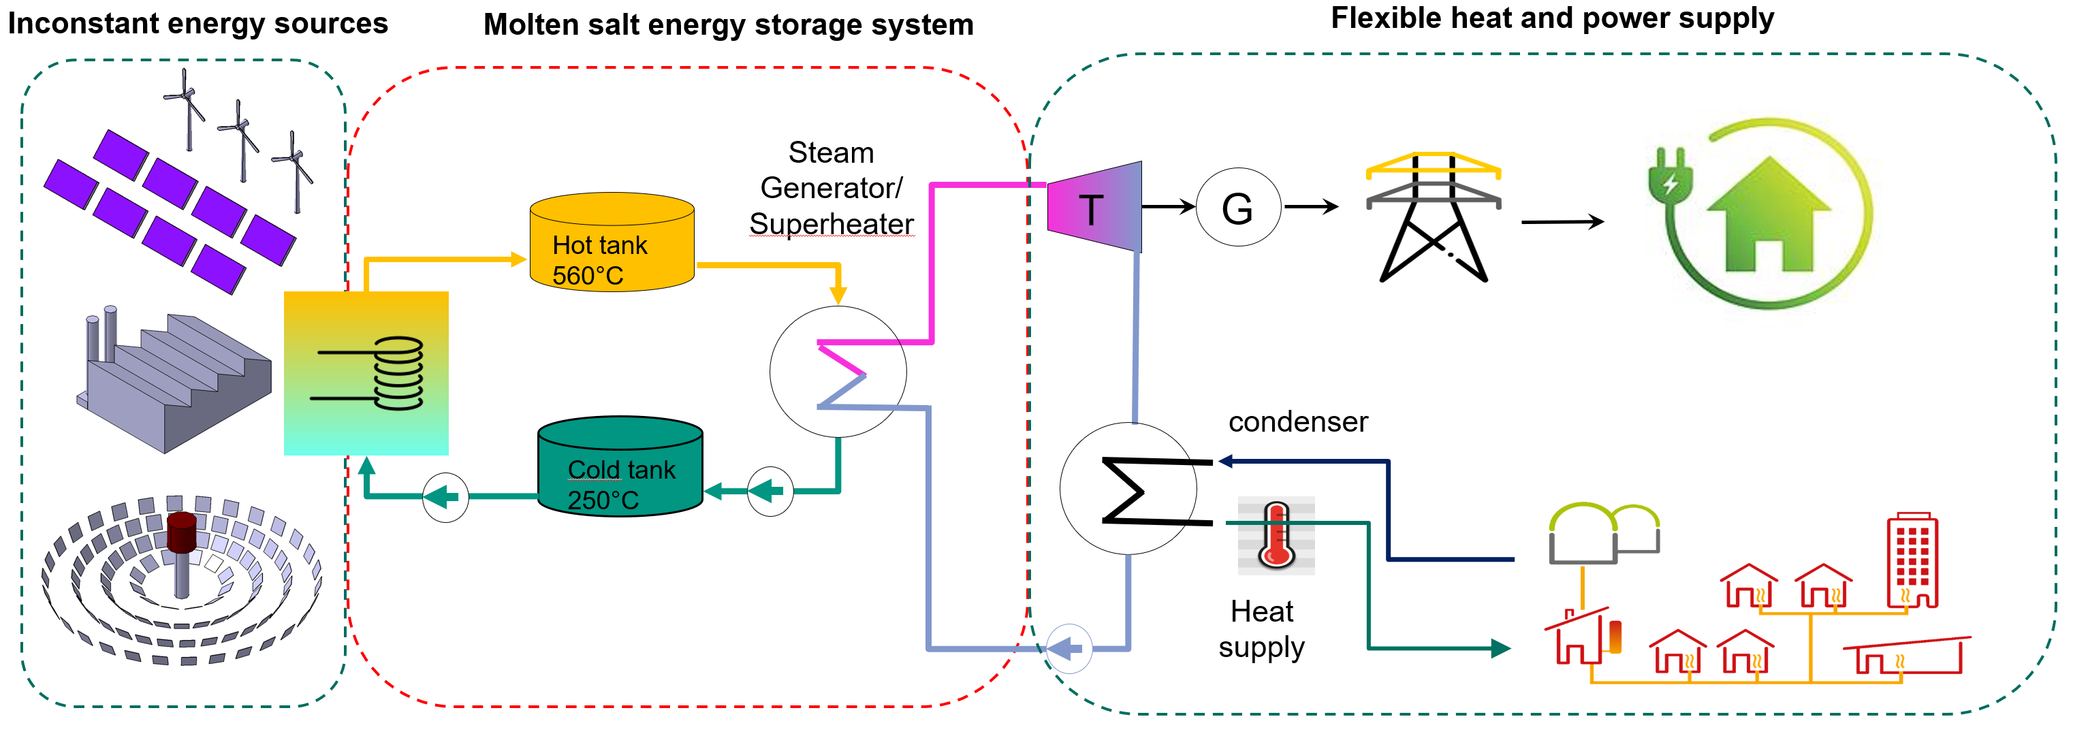

Tasks:

- Develop smooth and finned tube modules in FLUENT-ANSYS with given heat transfer material and geometry
- Calculate the fluid velocity and temperature fields in the of the shell and tube side of the heat exchanger
- Provide calculation results of several geometry options

Your profile:

- Experience in Fluent Ansys application
- Specialization in mechanical Engineering or in similar areas
- Have finished the course on mass- and heat transfer in bachelor study
- English or German as working language and in thesis

Begin:
possible now

Contact:
Dr. Xiaoyang Gaus-Liu, ITES, KIT
Email: xiaoyang.gaus-liu@kit.edu

